Q.1.Create a domain named **Gold.local** and Join the Windows client to the domain you created. Verify if you can login from the client using a non- admin domain user. Also install **Additional Domain Controller (ADC)**

**Ans:- Step 1-Add roles and Features(Select destination Server)**

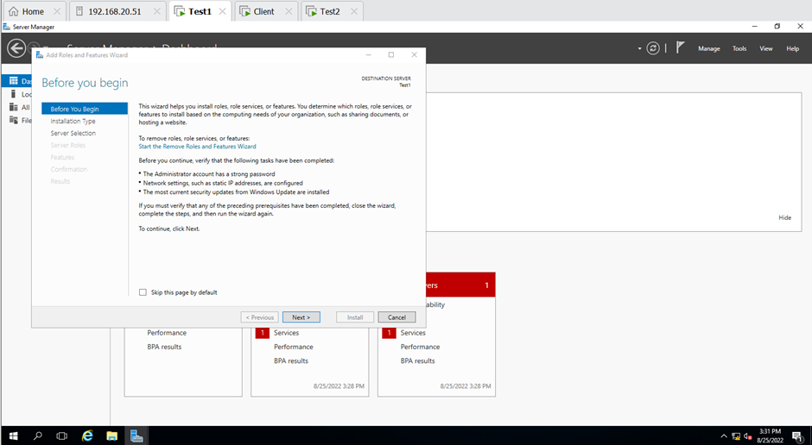

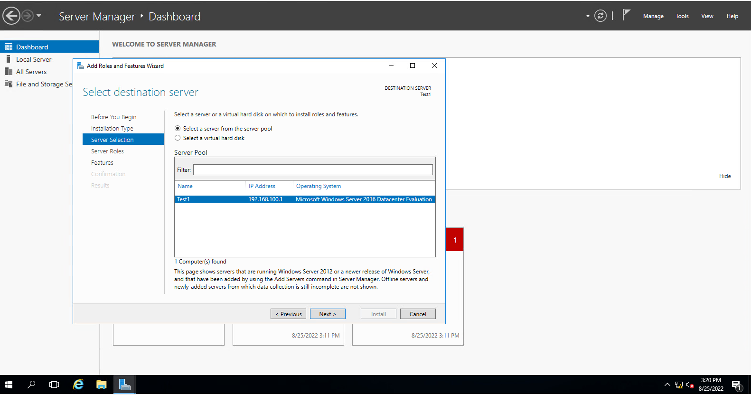

Step 2 :- Select Server Roles(Active Directory Domain Services)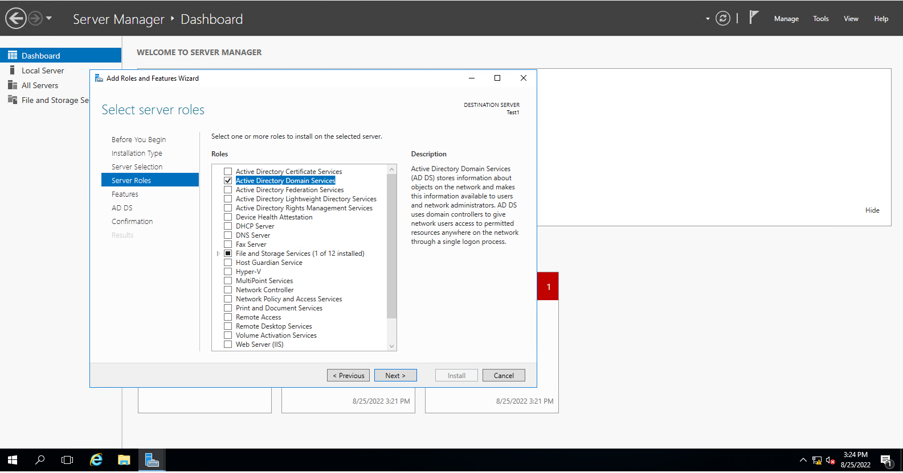

Step 3:- select features

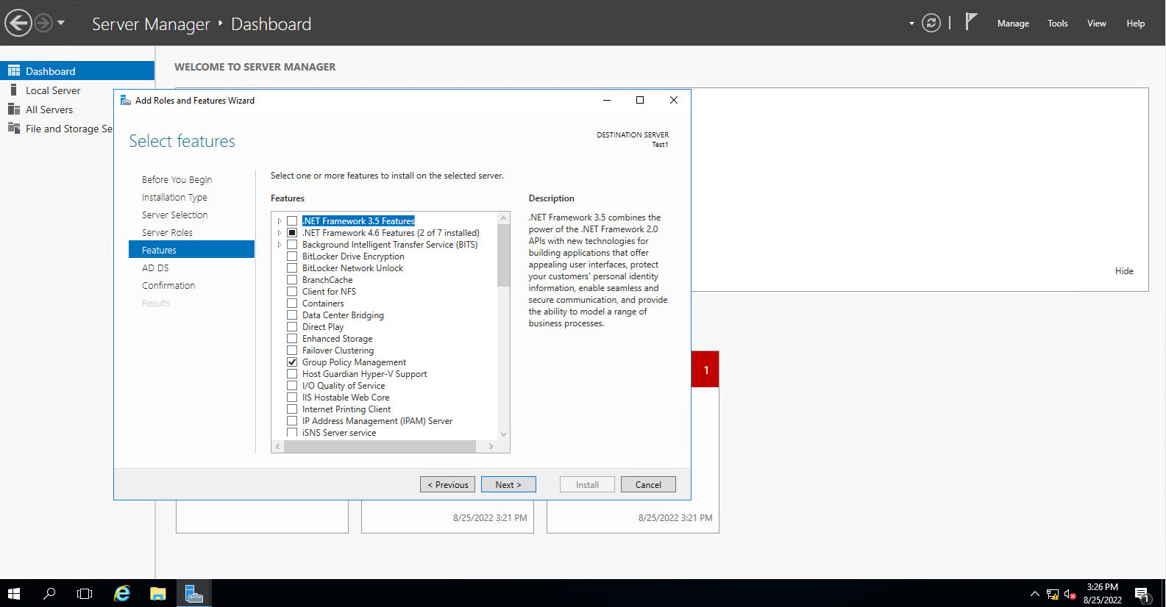

Step 4:- Deployment Configuration

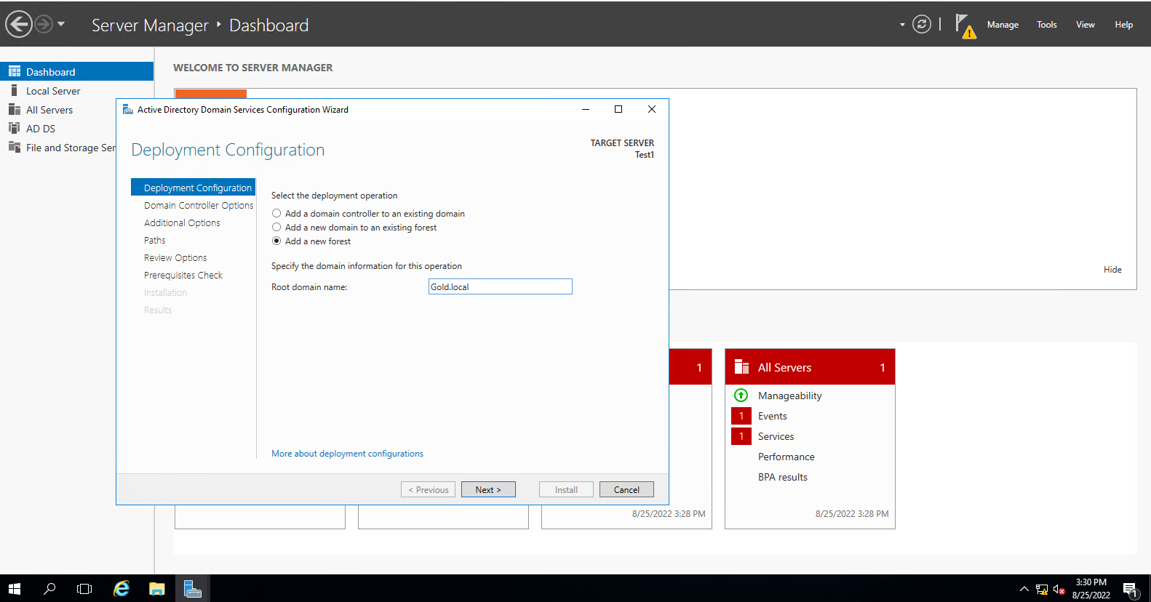

Step 5 :- Domain Controller options

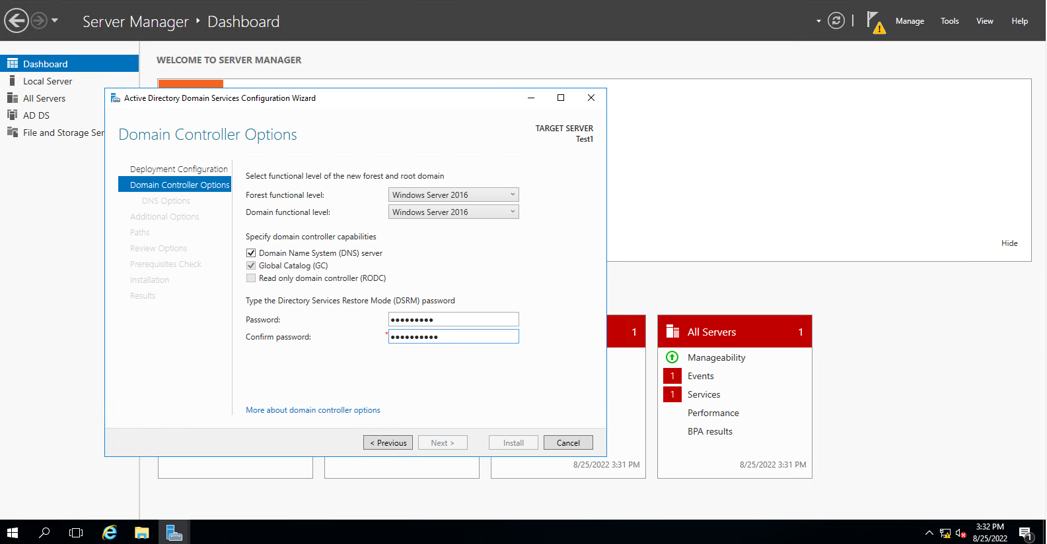

Step 6:- The server was successfully configured as a domain controller

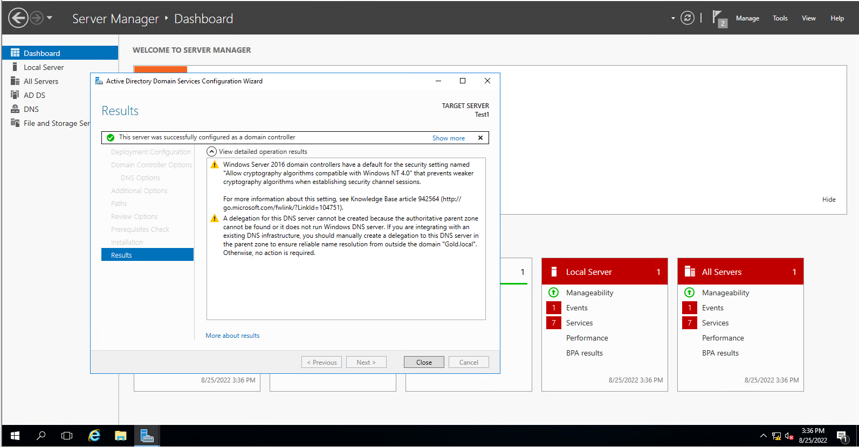

Step 7:- **All the Steps done in Test 1**

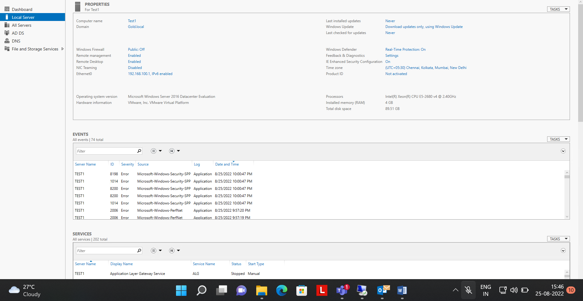

Step 8 :-Select destination server for Test2

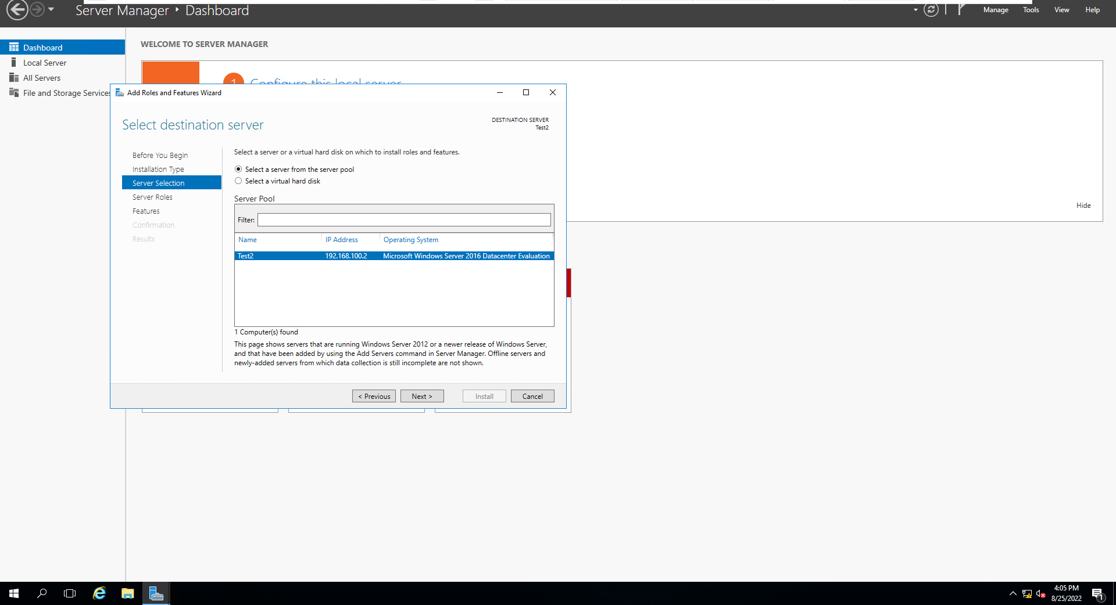

Step 9:- Sucessfully connected Test2 with Test1

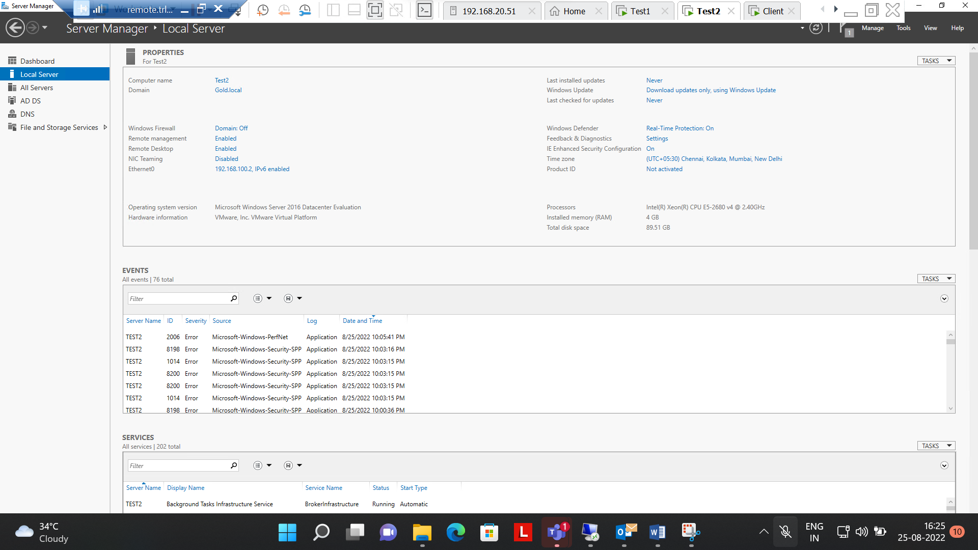

Step 10:- Succesfully connected Client with Test 1

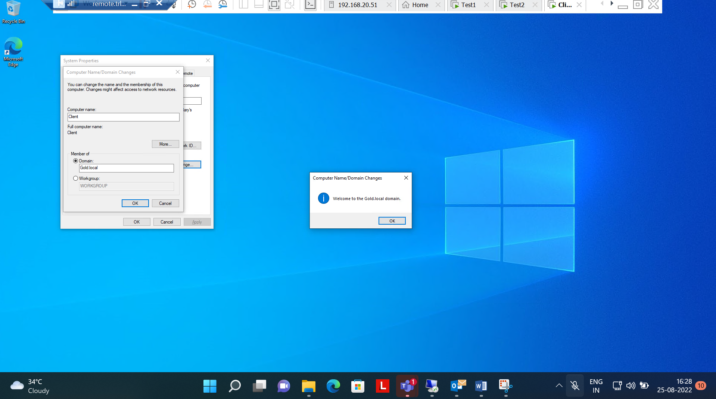

Step 10 :- Successfully login from the client using a non- admin domain user.

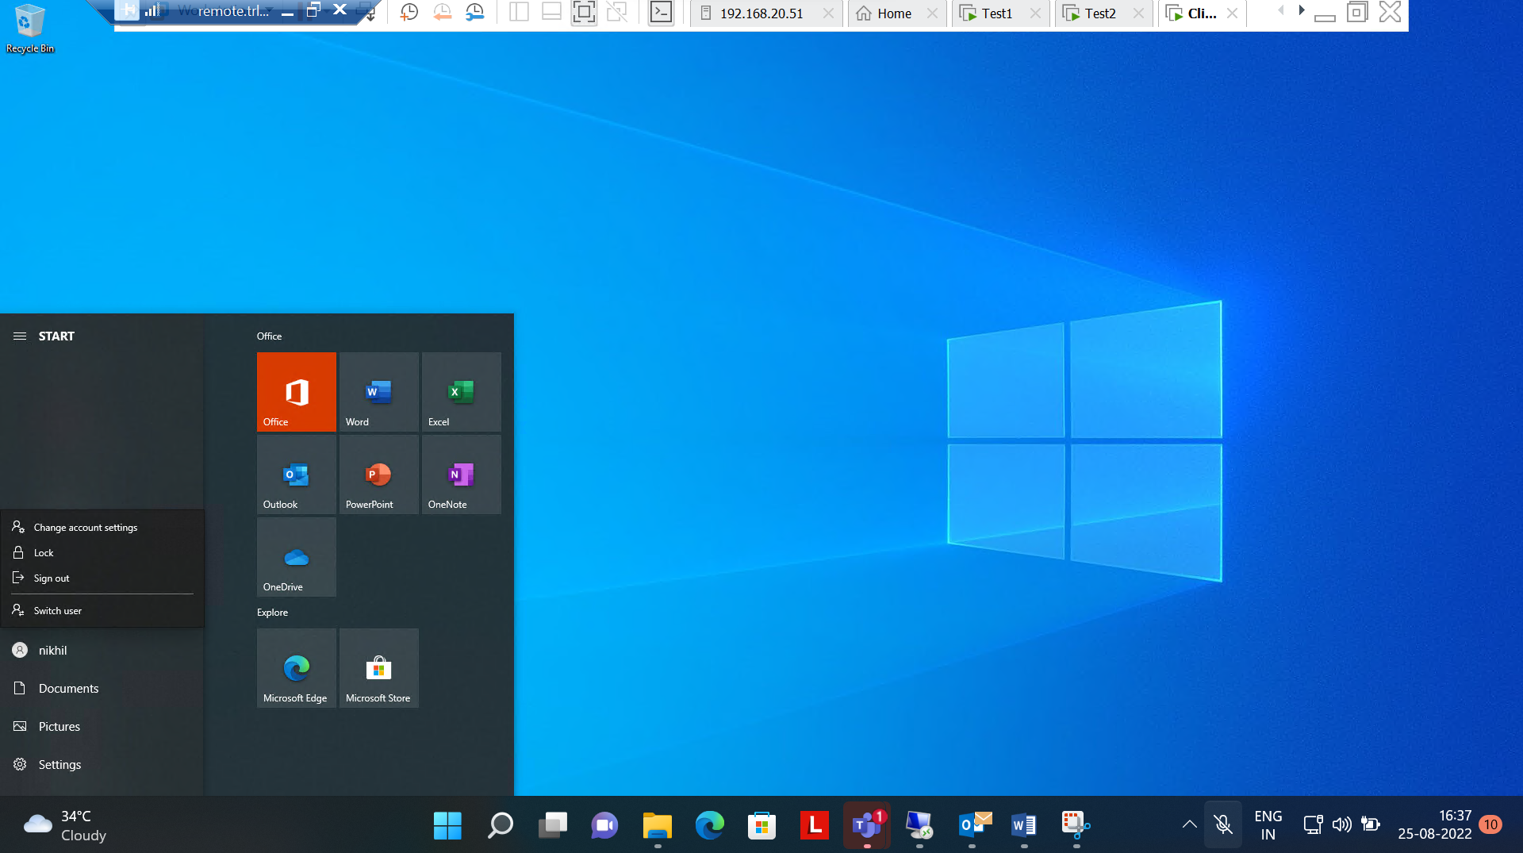

**Q. 1 completed.**

Q2. Perform all tasks related to DNS including all types of DNS records creation, Create Forward Lookup Zone, Create Reverse lookup zone. Display the current DNS Cache, Clear the current DNS Cache. Verify if all records are getting resolved from the ClientOS.

Ans:-

Step 1 :- Created Forward lookup zone and reverse lookup zone and then checked its working or not in client CMD with writing both name and address.

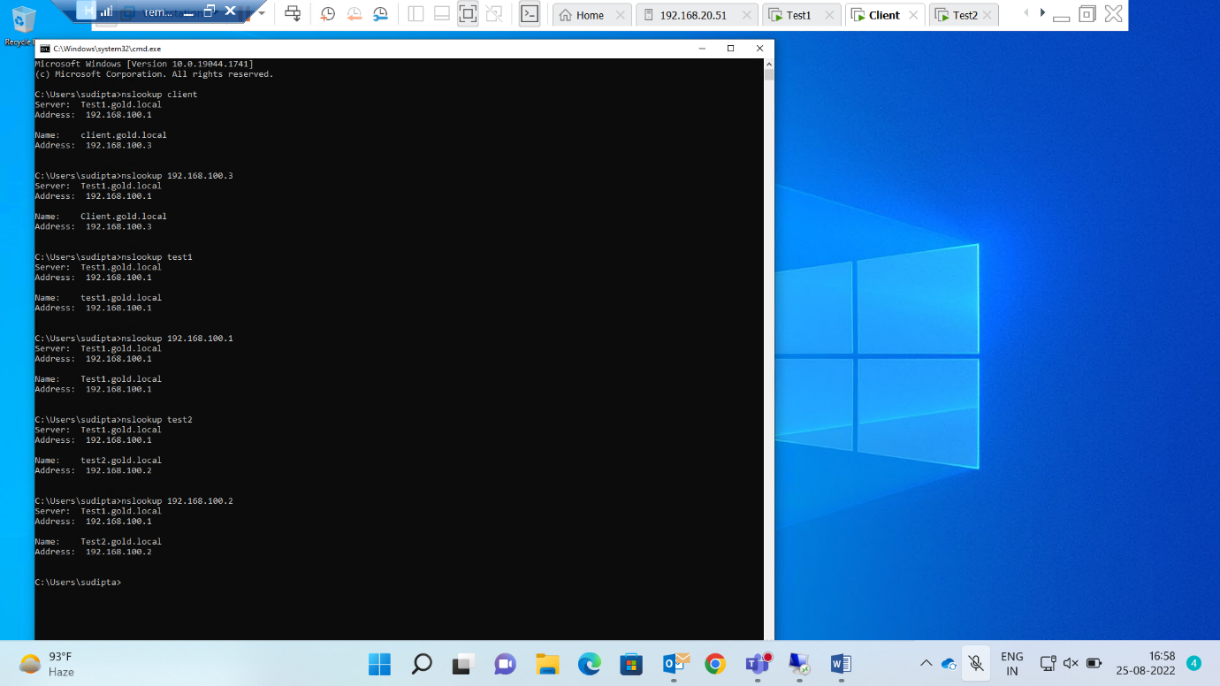

step2 :- Display the Current DNS Cache

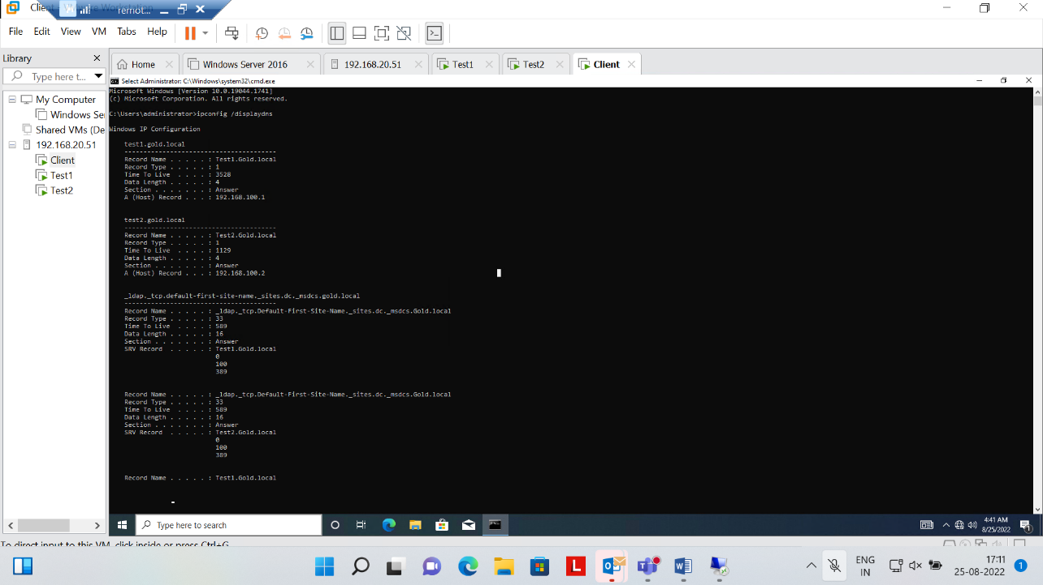

Step 3 :- Clear the current DNS Cache

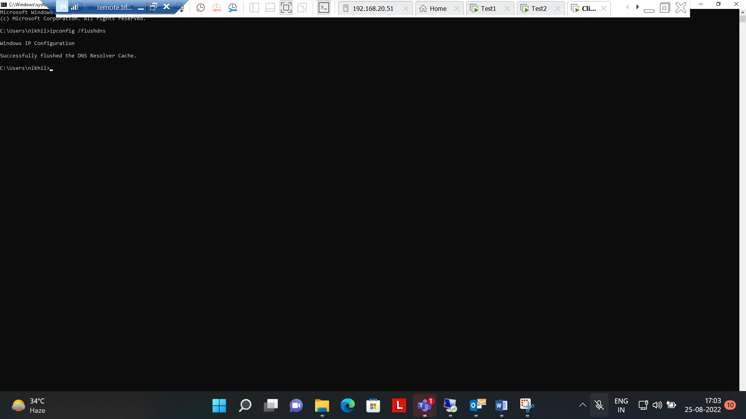

**Question No2 is Completed.**

**Q3. Clients should get dynamic IP address every 5 hours. Scope 192.168.100.100 to 192.168.100.200 and exclude starting and Ending IP address.**

Step1. Successfully Installed DHCP server.

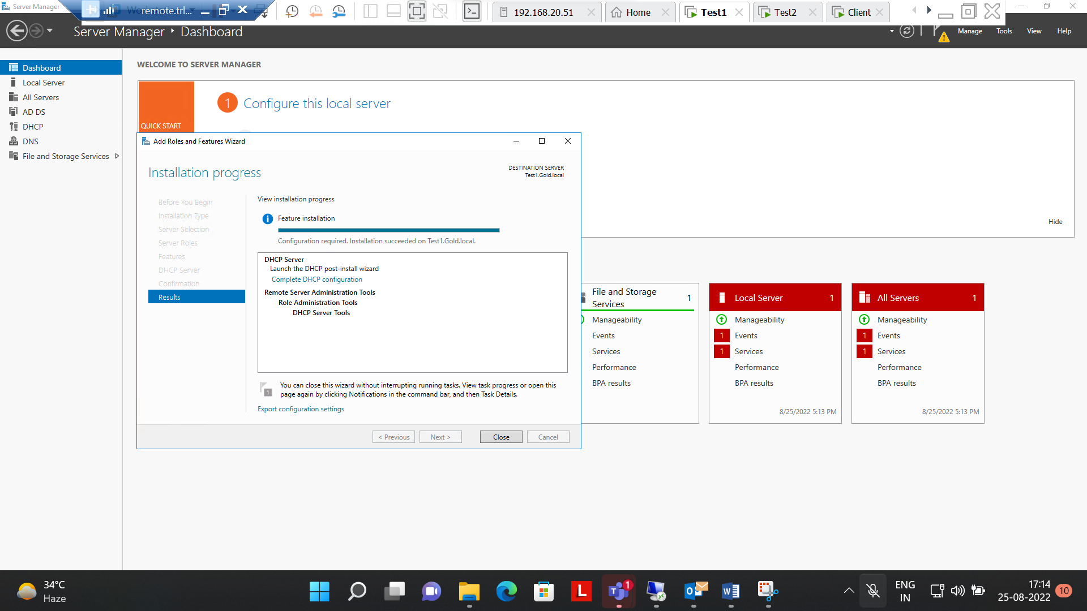

Step 2:- Set the Range of IP address from 192.168.100.100 to 192.168.100.200

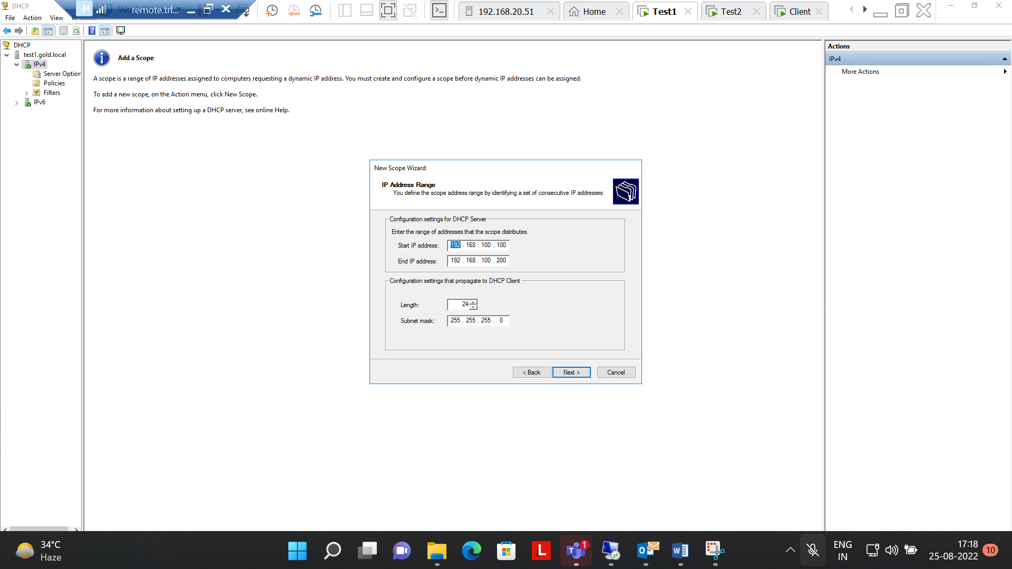

Step3:- excluded starting and Ending IP address

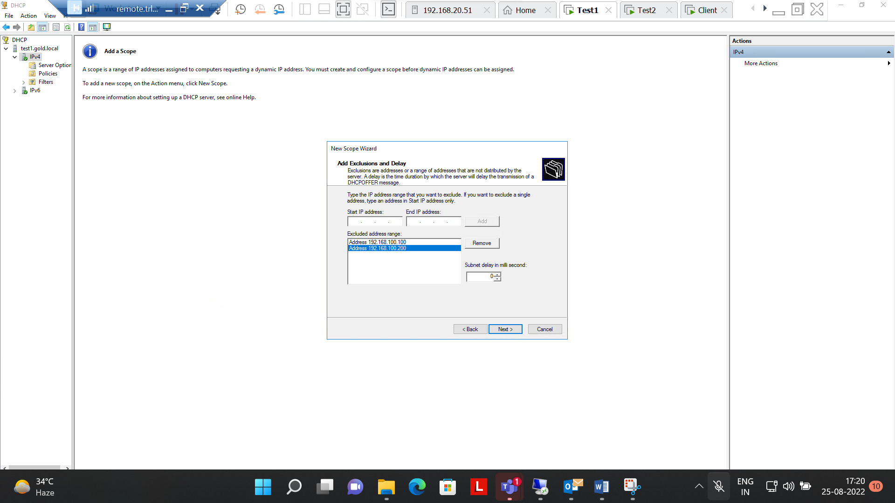

Step 4:- Clients will get dynamic IP address every 5 hours

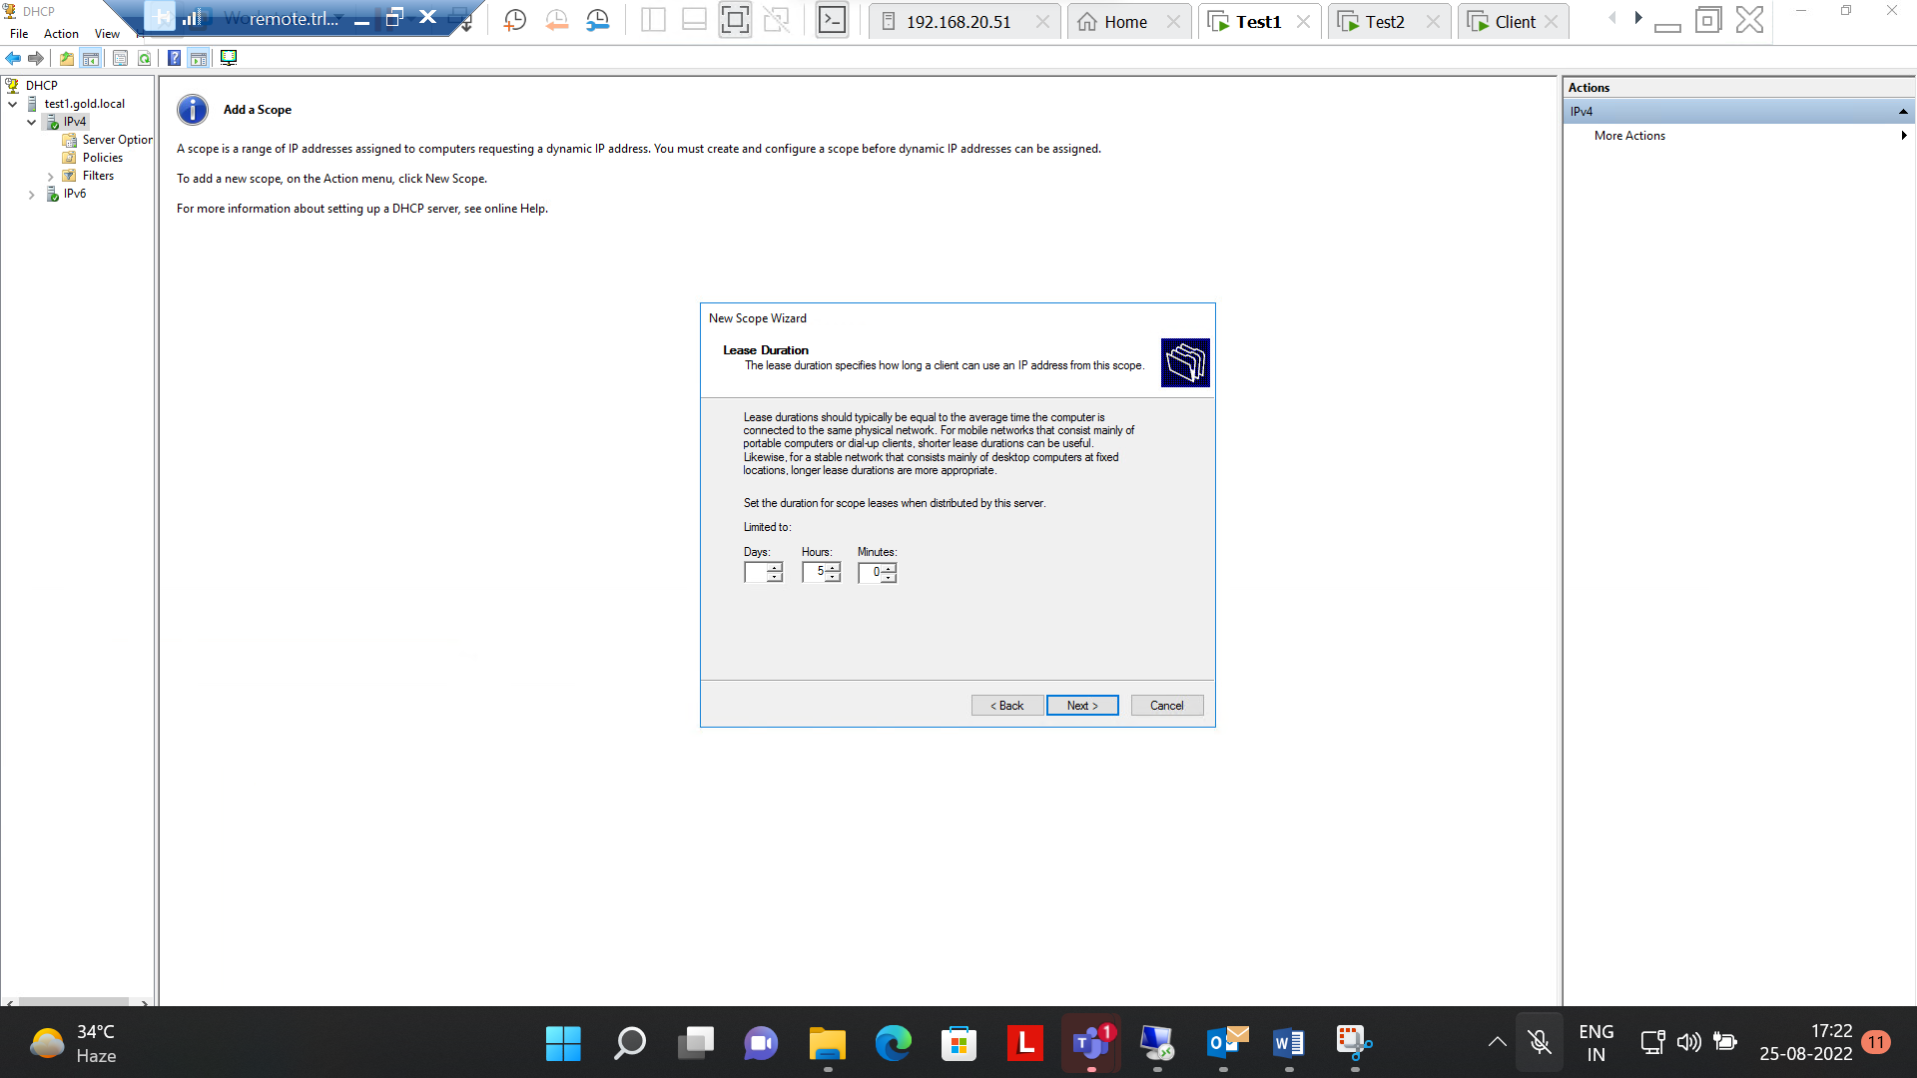

Step 5:- set the Router (default gateway)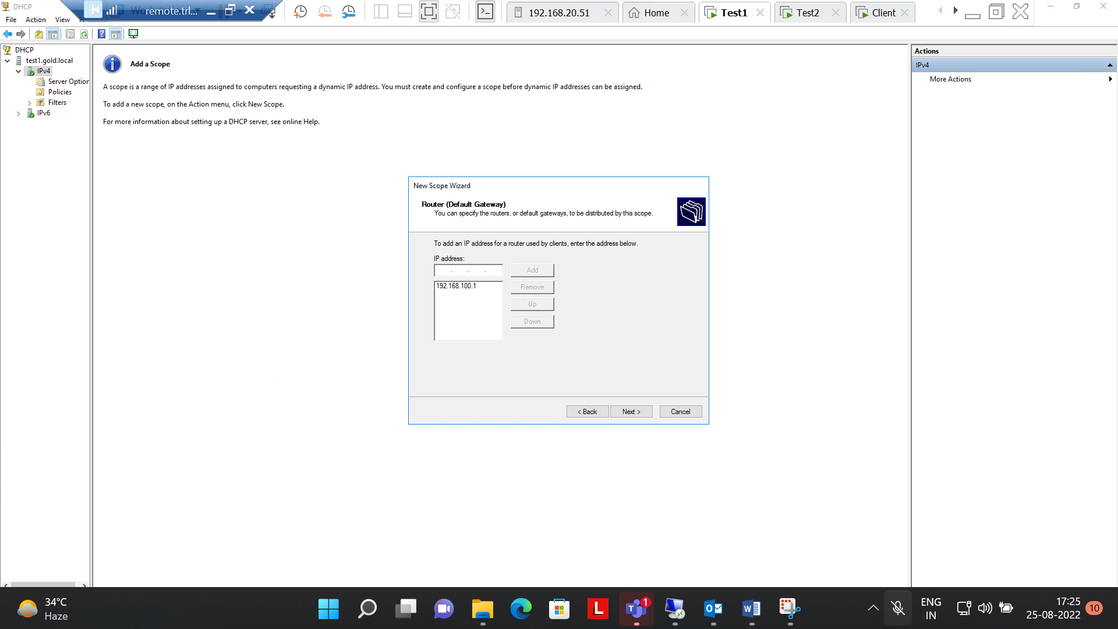

Step 6:-

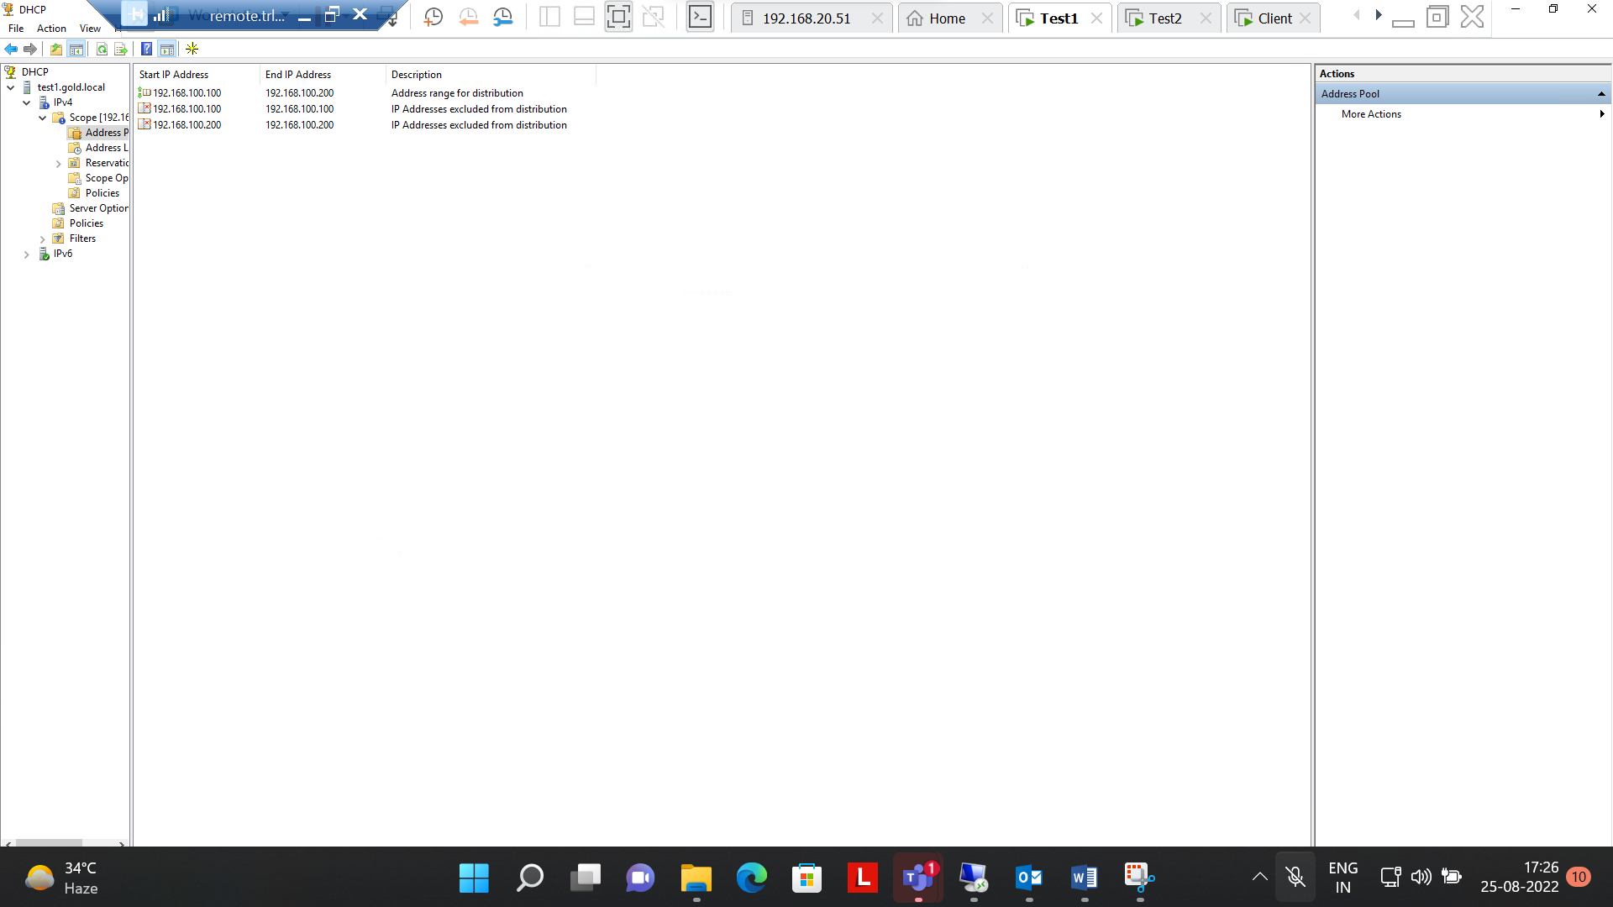

Step 7:- Automatically IP address is been assigned to the client.

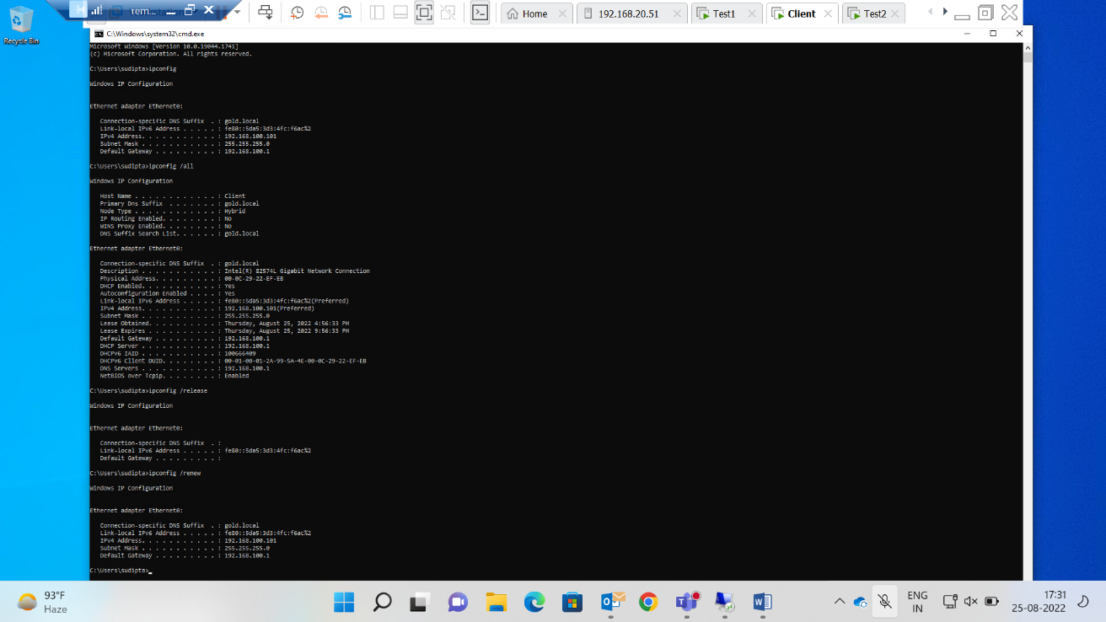

**Q.3 is now completed .**

Q 4.Create below mentioned OU’s and users, groups. Group members are from own OU.

|  |  |  |  |  |  |
| --- | --- | --- | --- | --- | --- |
| Organizational Unit | | Users | | Group Name | |
| IT | | Adam, Siri | | ITgroup | |
| Sales | | Aditya, Amanda | | Salesgroup | |
| HR | | Kin, den | | HRgroup | |

Ans:-

Step1.created Users and Groups

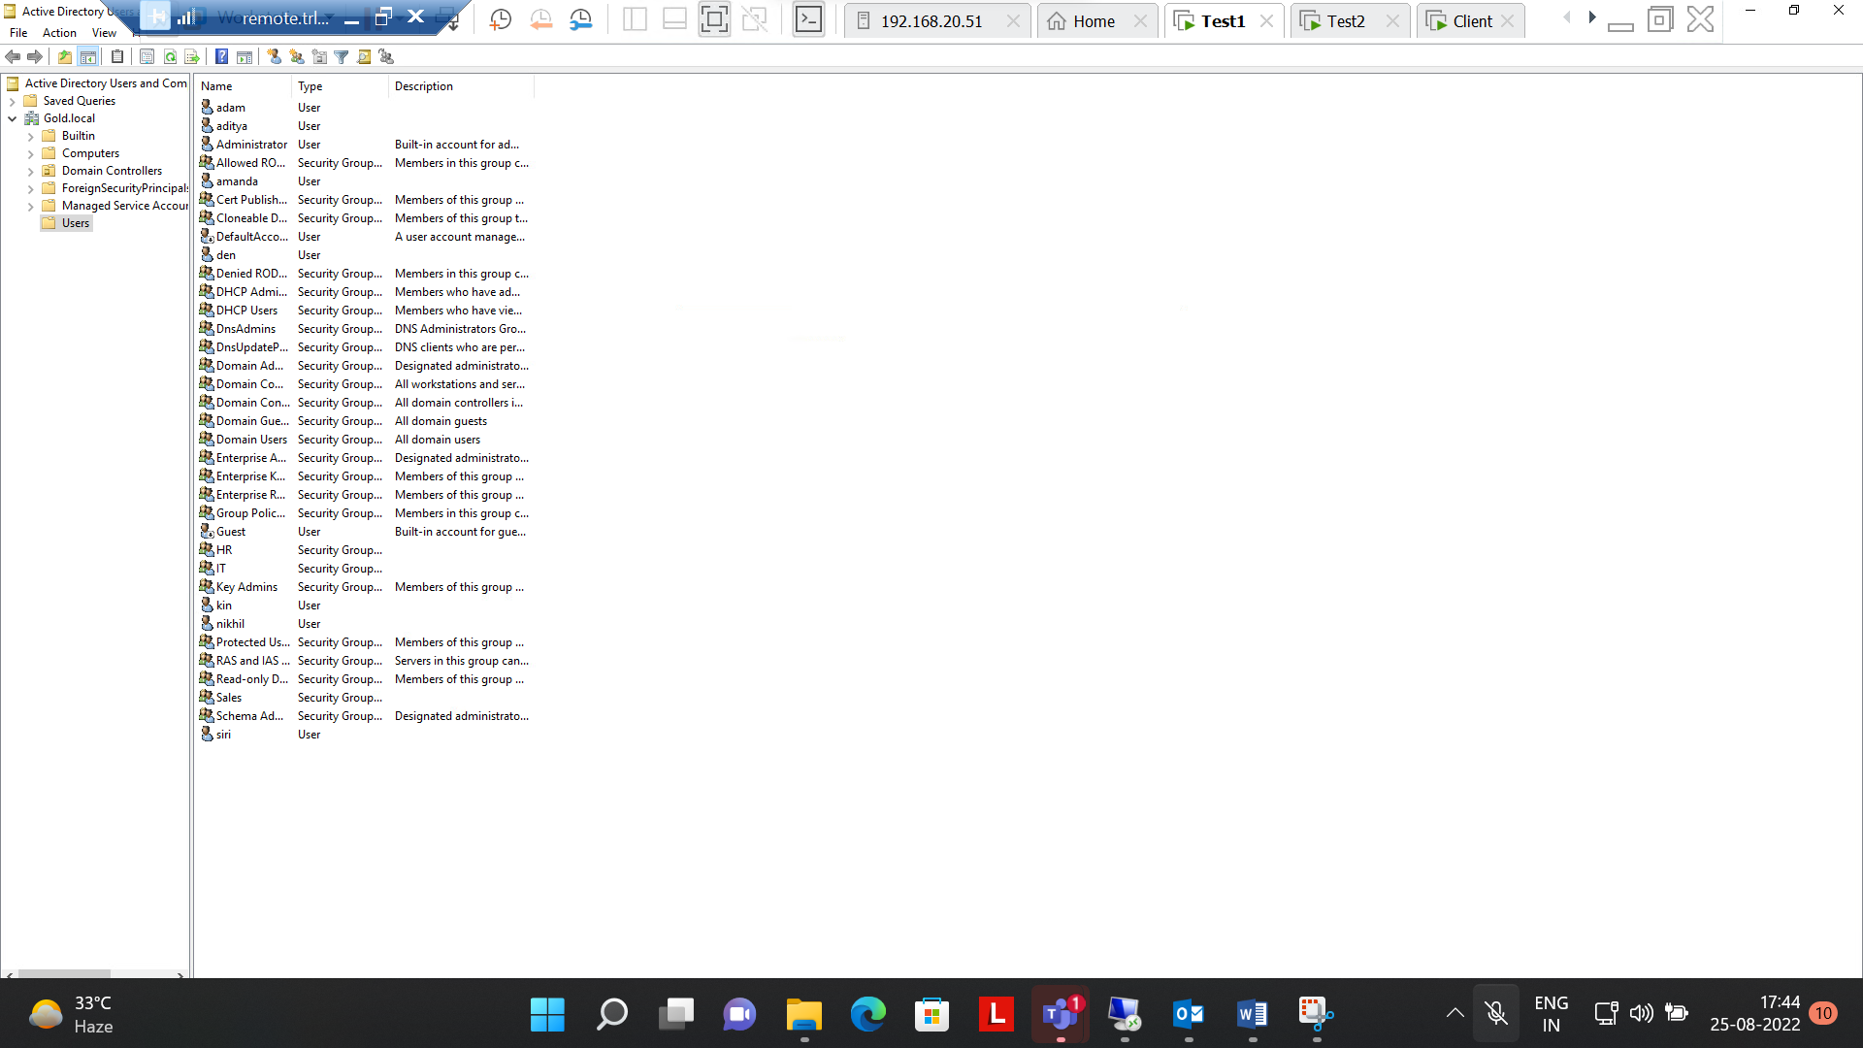

Step2:- Organizational Unit for IT

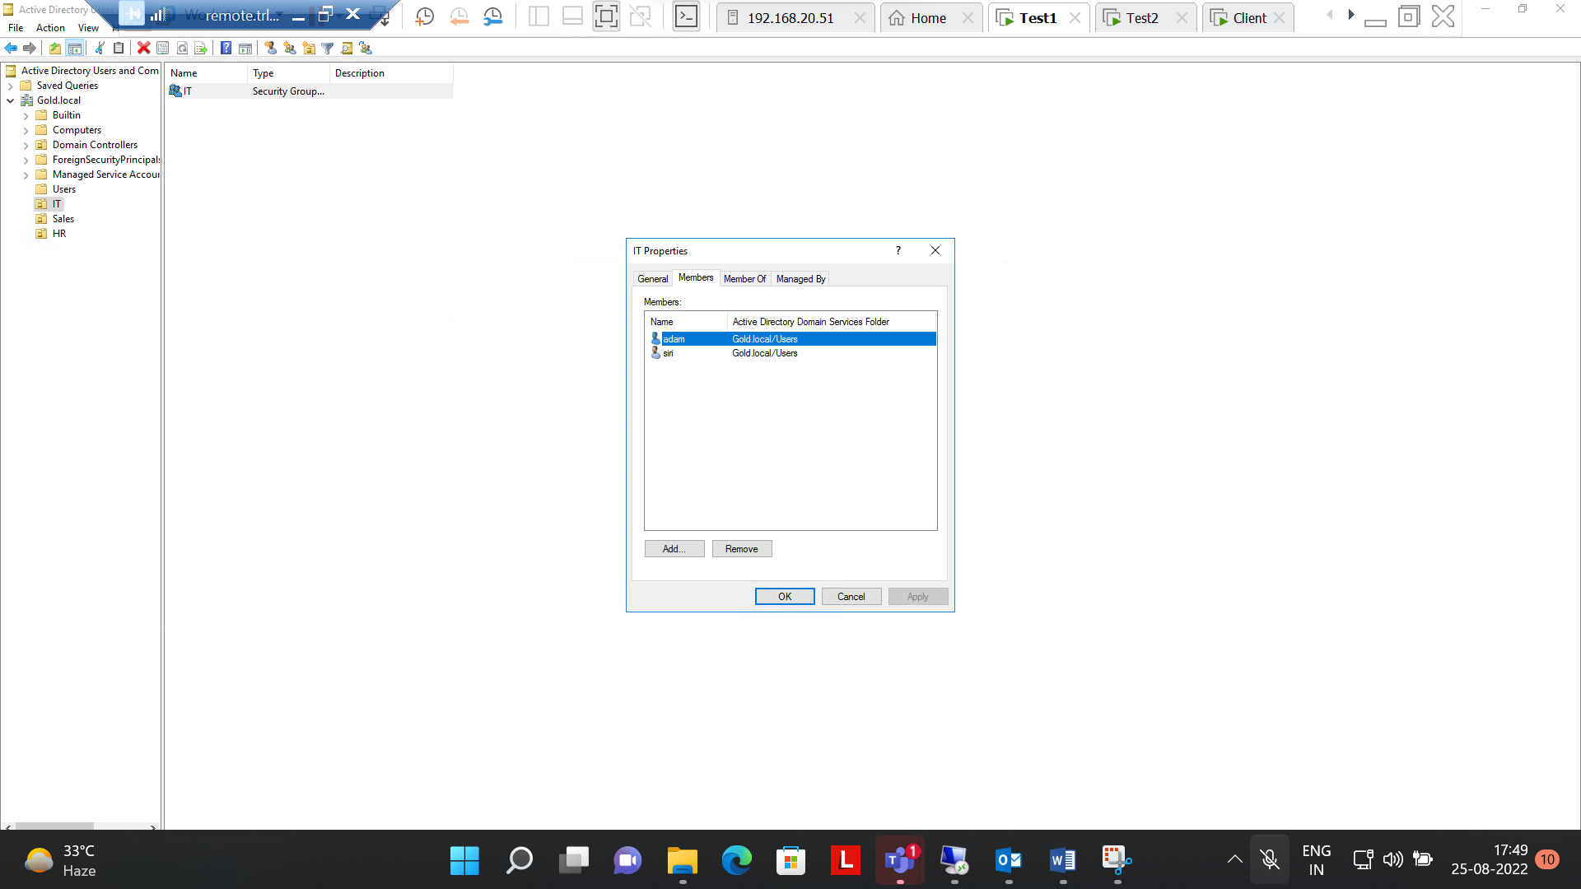

Step 3 :- OU for Sales

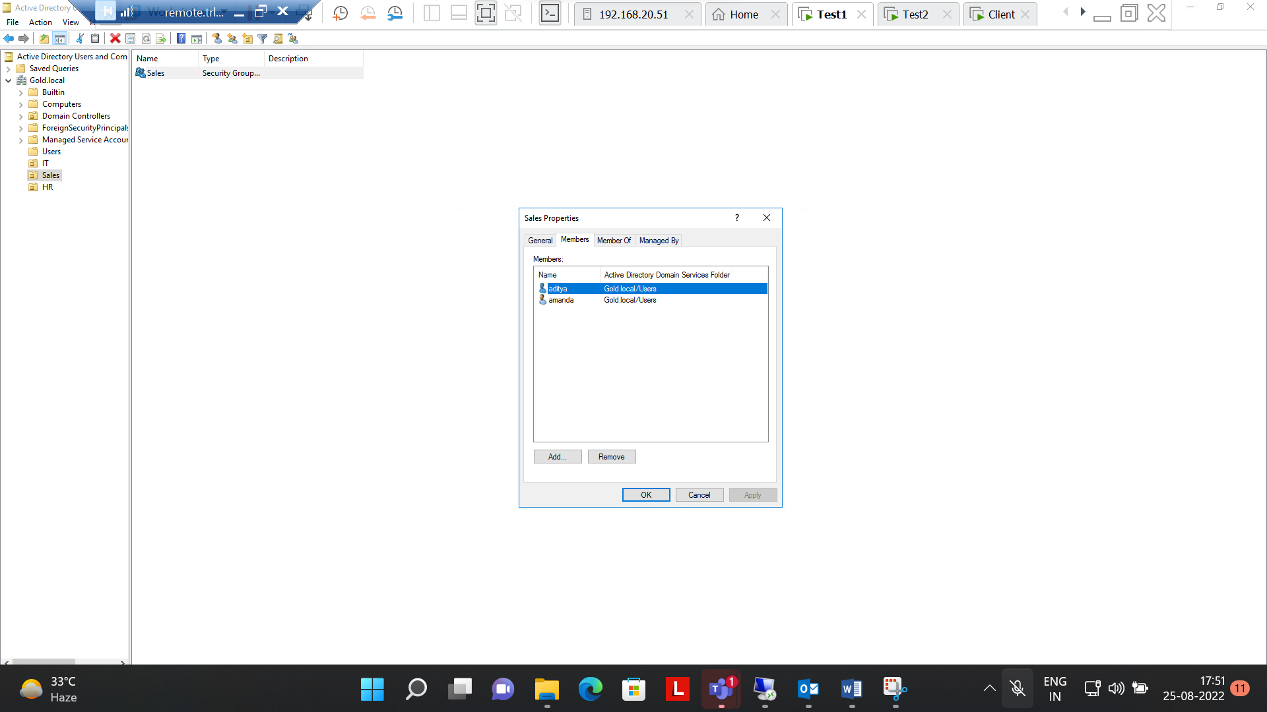

Step 4:- OU for HR

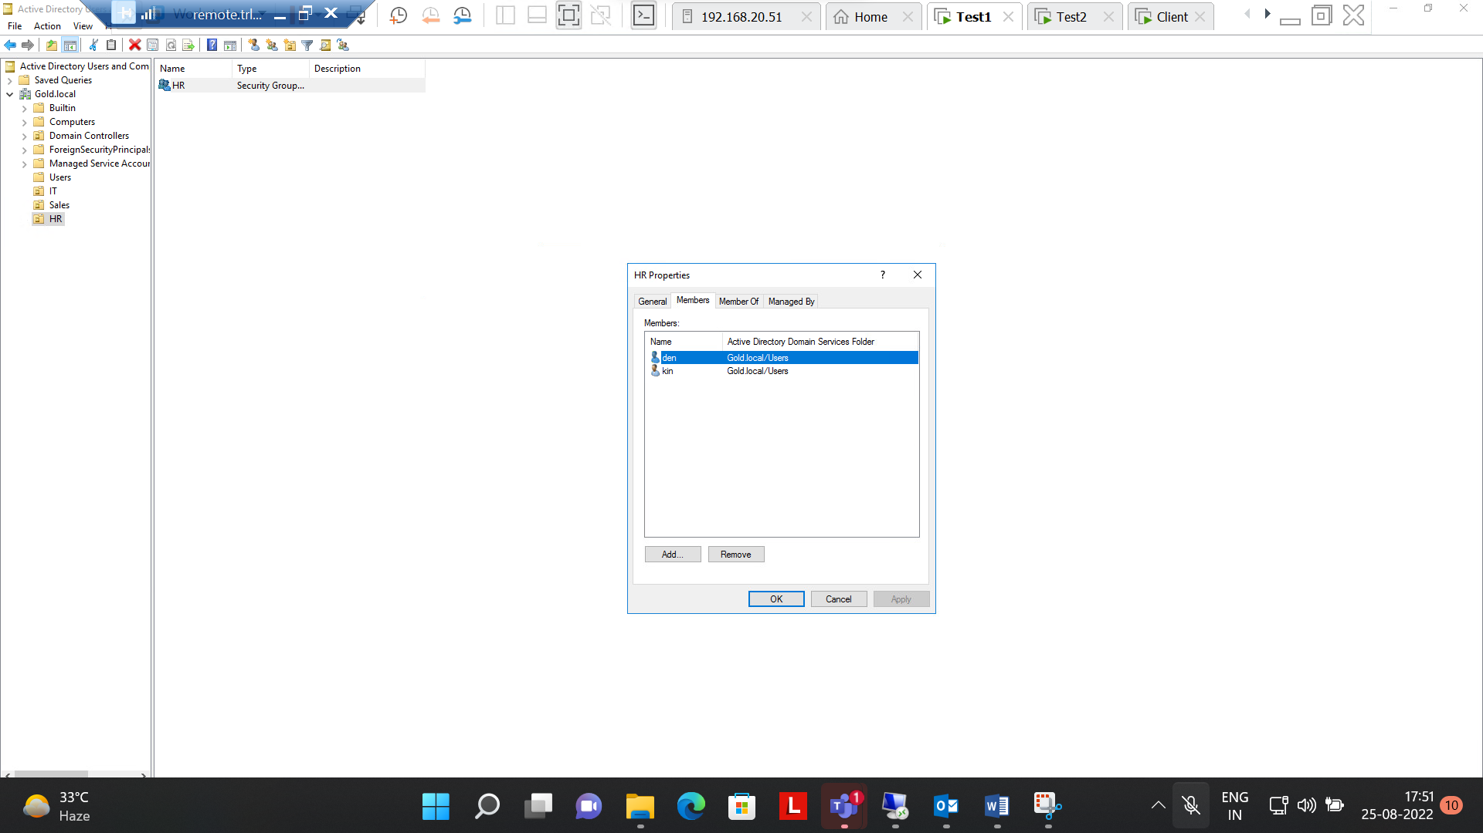

Step 5:- LOGIN Adam from IT in Client machine

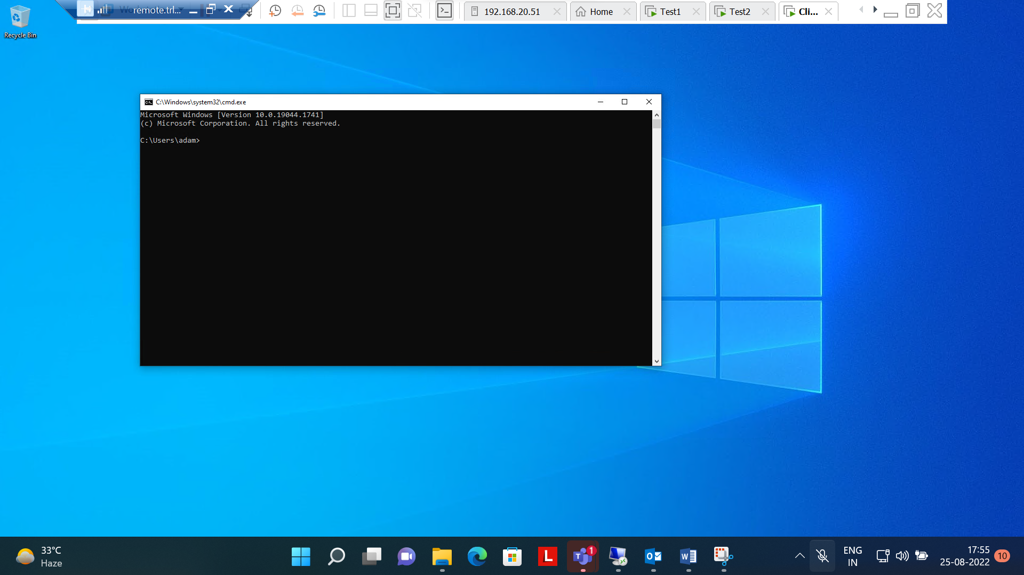

Step 6:- LOGIN Aditya from Sales in Client machine

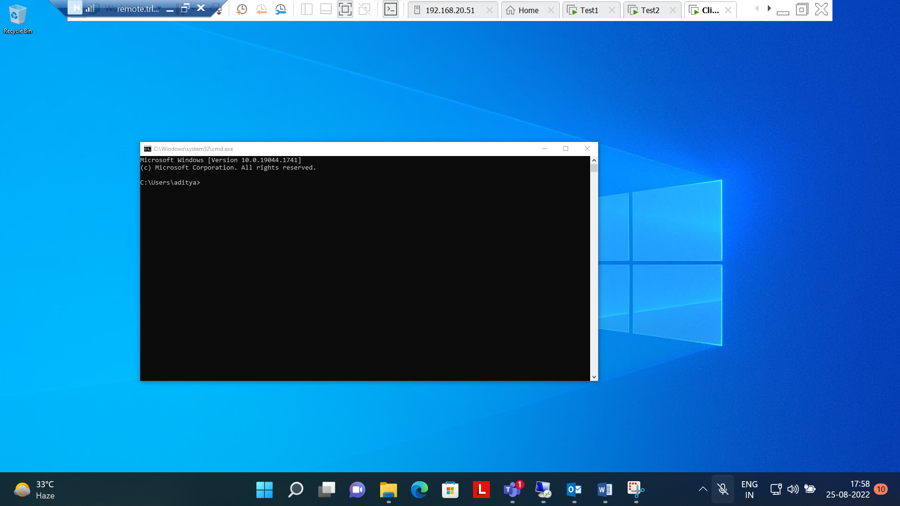

Step 7:- LOGIN Kin from HR in Client machine

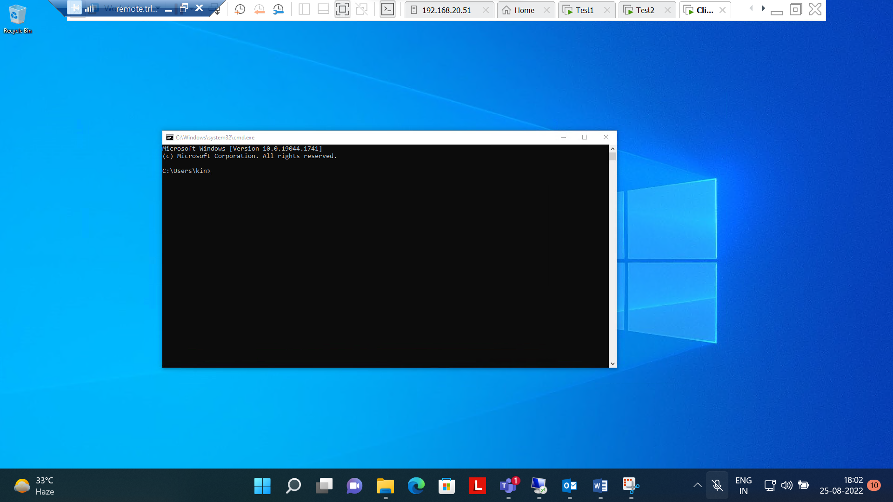

**Q4 is Completed successfully .**

**-**

**--All Four questions have been completed .----**